BRANCH COUNTY

4-H AND FFA HORSE

PROJECT NOTEBOOK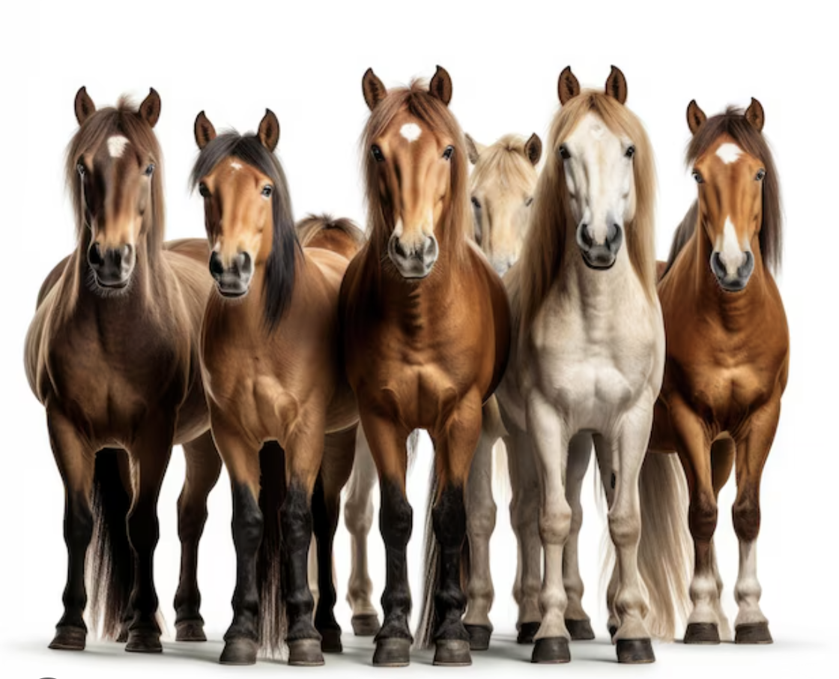

Name____________________Age_____

4-H Club____________Year in 4-H_____

Year in Horse Project__________

Intermediate Division (4-7 years of 4-H in horses)

Branch County 4-H Horse Notebook

***All members must complete pages 1-6***

***and at least one of the approved topics.***

I.

MY PROJECT PLANS

My project goals for this year:

PHOTO OR PICTURE THAT BEST PORTRAYS MY HORSE PROJECT:

1. ABOUT MY PROJECT:
   1. I am showing _______(number) of horses/ponies at the fair.

2. Name Breed Age Color

1. I show my projects in:

1. The equipment that I use is: (specify for each project and discipline)
2. Feed
   1. I feed my horse/pony this type of feed, supplements, and hay:
   2. The amounts of feed, supplements, and hay that I feed per animal, per day are:
   3. If you feed supplements, what are their purposes?
3. Preventative Care  
   1. I vaccinated my animal(s) for the following diseases:
   2. What is Equine Infectious Anemia?

3. How is it transmitted?

* 1. What type of dewormer do you use?

4. What parasites does it eliminate?

1. The Healthy Horse
   1. What is the normal Respiration rate of a horse?
   2. What is the normal temperature range of a horse?
   3. What is the normal heart rate of a horse?
   4. Has your horse had it’s teeth floated this year?

Why is it important to have a horses teeth floated yearly?

1. My 4-H Experiences

1. What did you learn to do with one of your projects this year?

1. What 4-H or FFA activities did you participate in this year?

3. What is your favorite part of owning a horse?

4. What, if any, shows did you attend this year?

5. How has the horse project made you a better 4-Her or FFA member?

I have chosen to complete the following approved topic:

1. **PROJECT PICTURES-RECOMMENDED BUT NOT REQUIRED**

CHOOSE ONE OR MORE TOPICS AND DISCUSS AND DETERMINED BY NOTEBOOK GUIDELINES.

~Proper first aid kit- items and uses.

~List at least 3 parasites- tell what they affect, prevention, and control.

~Horsemanship- Western or English- mounting, dismounting, position of the hands, legs, and body, use of aides.

~Safety precautions- Stalling

~Judging- conformation and way of going of at least one breed/type of horse.

~Diseases and ailments- at least 2-tell treatments and symptoms.

~Bandaging and care of wounds.

~Grains- discuss different types and compare

~Hays- types and how to determine quality

~ Any other topic approved by your leader.

Guidelines for Horse Project Notebook

1. Must be turned in at the Horse Leaders meeting immediately preceding the Fair. Each club must be turned in as a group in a box with a list of those members planning to exhibit horse projects at the fair.
2. If not submitted by the specified date, that member will not be allowed to exhibit a horse project at the fair.
3. Judges with a working knowledge of horses will be hired to read the notebooks.
4. Notebooks must be complete with appropriate answers in all sections.
5. A minimum of one topic must be chosen and discussed each year. It must be attached to the first section.
6. The topic section may consist of pictures or diagrams illustrating techniques or a list. It may be essay form if desired.
7. All previous notebooks must accompany the current year notebook.
8. Notebooks should be presented in a binder.
9. If the notebook is less than 50% complete, no premium will be given.

Evaluation of Horse Project Notebook

Neatness (20 pts)……………………………….__________

Completed pgs 1-5 (25 pts)…………………..__________

Completed Topic (30 pts)…………………….__________

Accuracy of Information(25 pts)……………__________

Total Points………………………………………__________

Rating:

Comments:

Rating Scale:

A=81-100 points Completed for the year ____

B=65-80 points

C=51-64 points

No Rating=0-50 points

Signature of Reader:___________________________________